No: SVGU/UO/Exam/2023/011 Date: 06.10.2023

**Exam Form-Filling Circular for BCA / IMCA**

The University Exam dates for BCA/IMCA Semester 1 have been announced. Students are requested to log in to the Student Portal with their **Student Login ID** and fill up the exam form and complete the payment of their exam fee online. The Hall Ticket will be generated only after successful payment of your exam fee.

**The last date for filling the forms is 14.10.2023**. In case of any difficulty, you can get in touch with the Admin Office at the University.

Follow the below links:

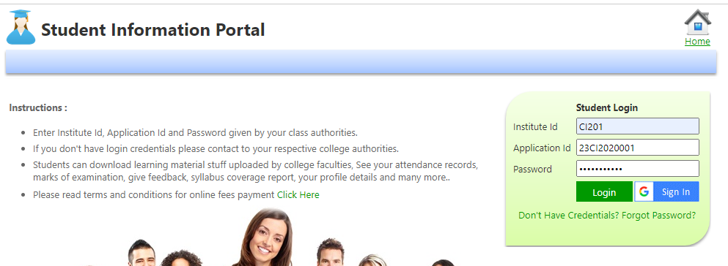

Select and click Examination Form:

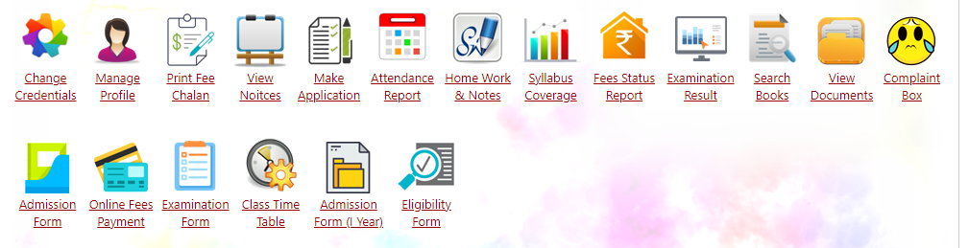

Click on Examination form:

Select in drop down in sequence:

For IMCA

For BCA

Click on Generate form then the form will display. Click on declaration. Once it is done click on submit.

After submission the below screen will appear:

Click on Pay fee and pay the fee online. It is compulsory to pay online.



**Registrar**